TITANIC DATASET ANALYSIS REPORT

COURSE: INTRODUCTION TO DATA SCIENCE WITH PYTHON
COURSE CODE: BCS 404

Dataset from Kaggle: Titanic Dataset https://www.kaggle.com/competitions/titanic/data TITANIC_DATASET_1309.xlsx

Prepared By: Prince Nana Kwame Osei Mensah
Index Number: 01259382B

Tools Used:
Python
Pandas
NumPy
Matplotlib
Seaborn
Scikit-Learn

Date: 10TH July 2026

Table of Contents
1.0 INTRODUCTION 1
2.0 DATASET DESCRIPTION 1
2.1 Dataset Features 1
2.2 Dataset Composition 1
3.0 METHODOLOGY 2
3.1 Data Preprocessing 2
3.2 Data Cleaning Procedures 2
3.3 Exploratory Data Analysis 2
3.4 Feature Selection 4
3.5 Model Development 4
4.0 Results 6
4.1 Descriptive Statistics 6
4.2 Passenger Distribution 6
4.3 Correlation Analysis 7
4.4 Logistic Regression Performance 7
6.0 CONCLUSION 9
7.0 REFERENCES 10
APPENDIX (PYTHON CODE) 11

1.0 INTRODUCTION
The Titanic disaster remains one of the most studied events in maritime history. On 15 April 1912, the RMS Titanic sank after colliding with an iceberg, resulting in the loss of more than 1,500 lives. The Titanic dataset has become a widely used dataset in data science and machine learning because it contains passenger demographic, socioeconomic, and travel-related information that can be analyzed to understand the factors affecting survival.
The objective of this project is to perform exploratory data analysis (EDA), statistical analysis, and predictive modeling on the Titanic dataset using Python. Specifically, the project aims to:
- Understand the structure and characteristics of the dataset.
- Identify key factors that influenced passenger survival.
- Perform data cleaning and preprocessing.
- Develop a classification model to predict survival outcomes.
- Evaluate the performance of the model using appropriate metrics.

2.0 DATASET DESCRIPTION
The dataset contains 1,309 passenger records and 12 variables describing passenger demographics, travel information, and survival status.

2.1 Dataset Features
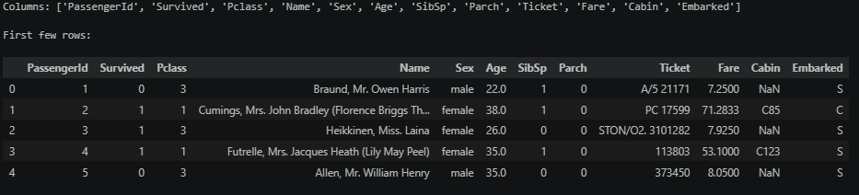

2.2 Dataset Composition
- Total Passengers: 1,309
- Total Variables: 12
- Survivors: 494
- Non-Survivors: 815
- Survival Rate: 37.7%

3.0 METHODOLOGY
The analysis followed a structured data science workflow.

3.1 Data Preprocessing
The dataset was assessed for missing values and duplicates.

3.2 Data Cleaning Procedures
- No duplicate records were identified.
- Missing values in Age and Fare were replaced using median imputation.
- Missing values in Cabin and Embarked were replaced using mode imputation.
- Dataset dimensions remained unchanged after preprocessing.

Exploratory Data Analysis
Exploratory analysis was conducted using descriptive statistics and visualizations to identify trends and relationships among variables. Visualizations included:
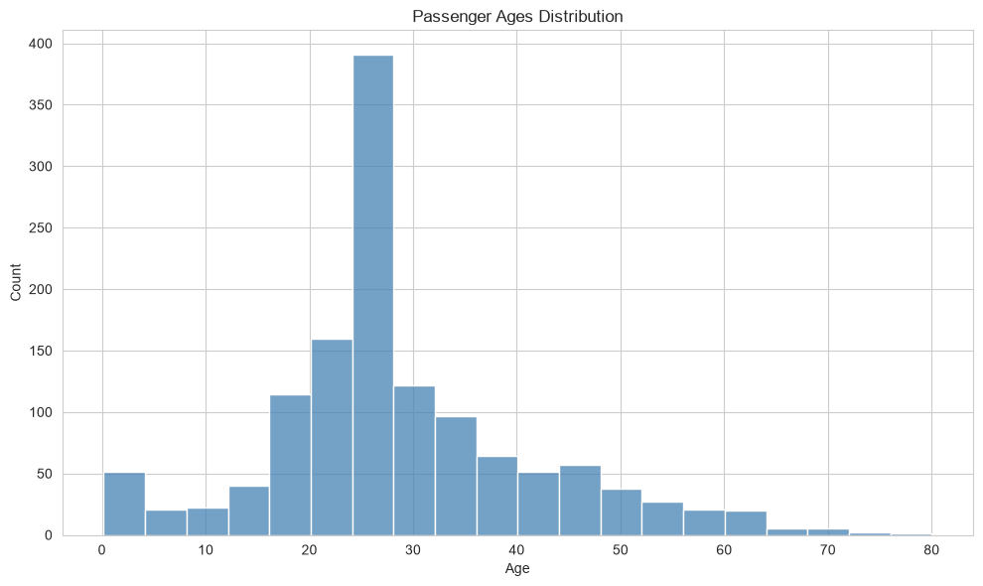
- Histograms

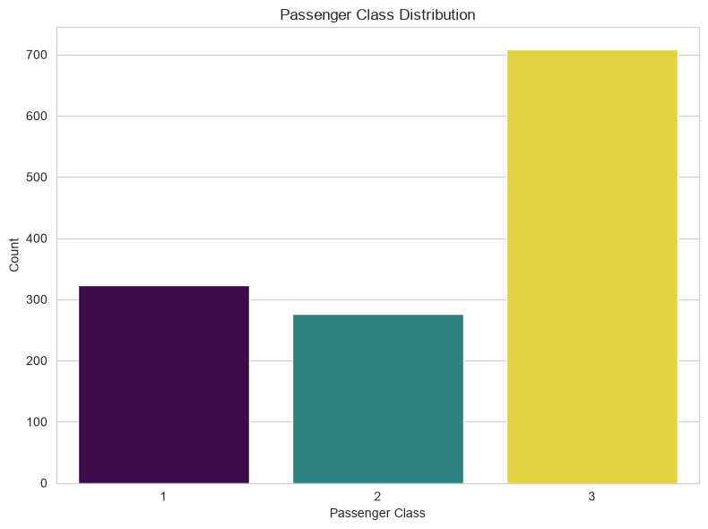
- Bar charts

- Scatter plots & Correlation heatmaps
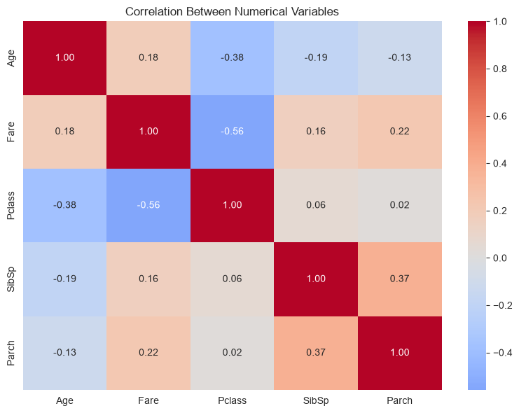
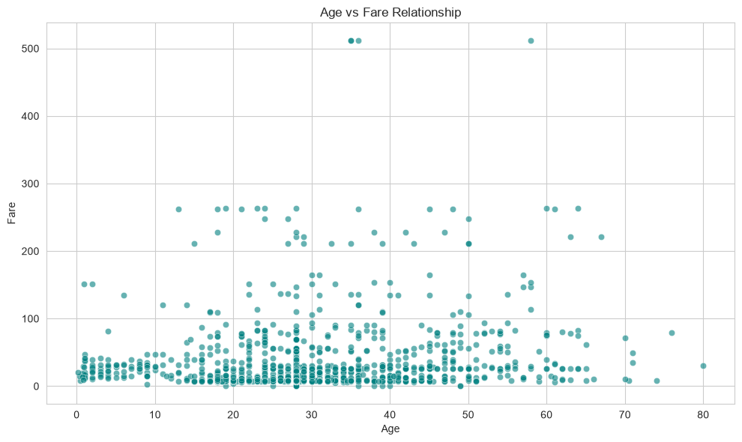

- Pair plots
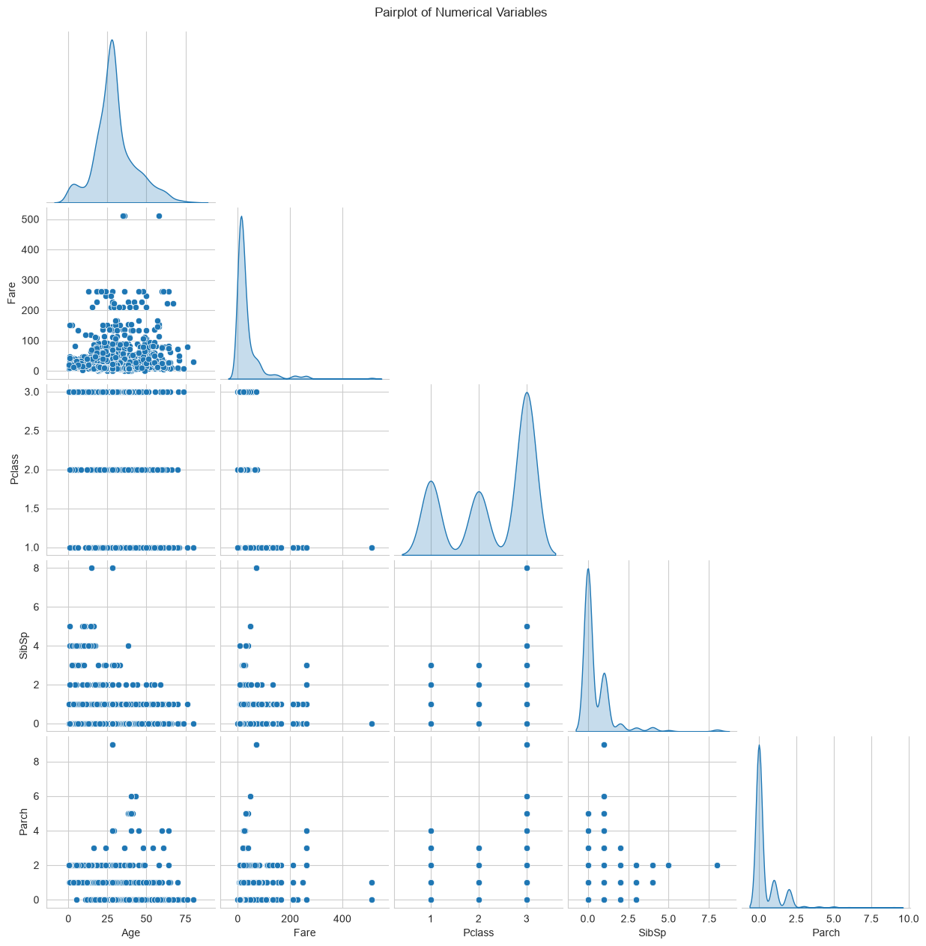

3.4 Feature Selection
The following predictor variables were selected:
- Pclass
- Sex
- Age
- SibSp
- Parch
- Fare
- Embarked
Target Variable: Survived

3.5 Model Development
A Logistic Regression classification model was developed using:
- StandardScaler for numerical variables.
- One-Hot Encoding for categorical variables.
- Stratified train-test split (70% training, 30% testing).
- Logistic Regression algorithm with 1,000 maximum iterations.

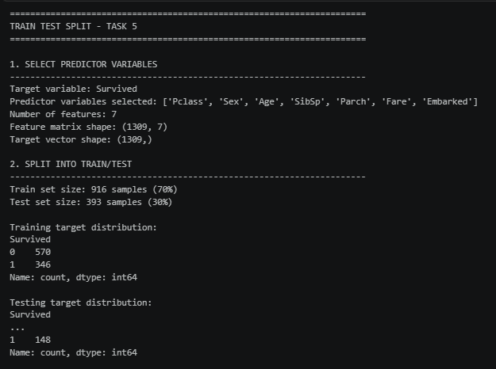

4.0 Results

4.1 Descriptive Statistics
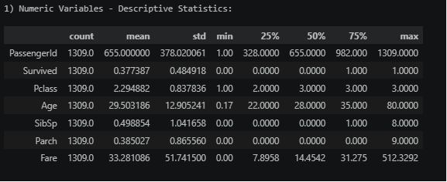
Most passengers were between 20 and 40 years of age, while ticket fares varied considerably due to differences in travel class.

4.2 Passenger Distribution
Passenger Class Gender
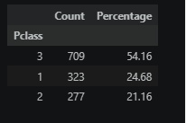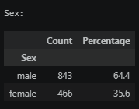

Port of Embarkation
Port | Percentage
Southampton (S) | 69.98%
Cherbourg (C) | 20.63%
Queenstown (Q) | 9.40%

4.3 Correlation Analysis
Key relationships identified include:

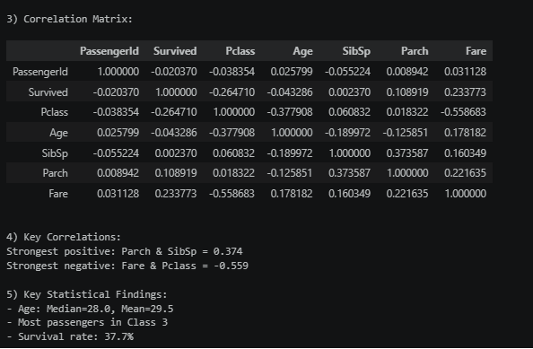
These findings indicate that higher-class passengers who paid higher fares generally had better chances of survival.

4.4 Logistic Regression Performance
Confusion Matrix
Actual/Predicted | Non-Survivor | Survivor
Non-Survivor | 227 | 18
Survivor | 38 | 110
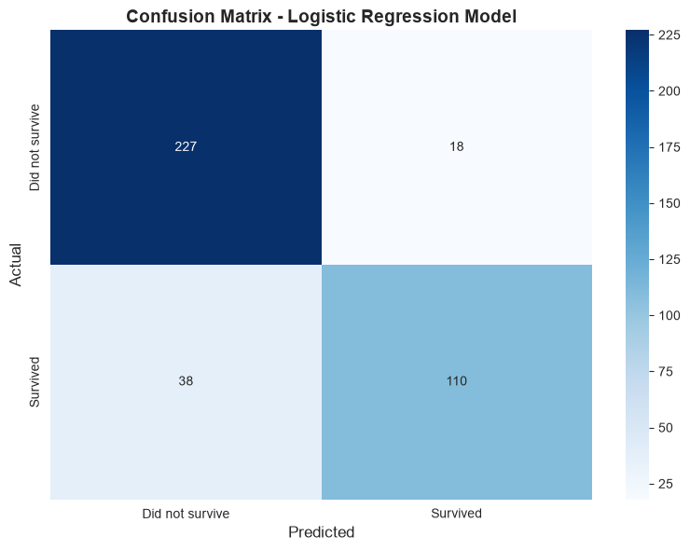
Performance Metrics
Metric | Value
Accuracy | 85.75%
Precision | 85.94%
Recall (Sensitivity) | 74.32%
Specificity | 92.65%
F1-Score | 79.76%

The model correctly classified approximately 86% of passengers in the testing dataset.

5.0 Discussion
The analysis revealed several important insights regarding passenger survival aboard the Titanic.
Passenger class emerged as one of the strongest predictors of survival. First-class passengers generally had greater access to lifeboats and crew assistance, resulting in higher survival rates than third-class passengers. The negative correlation between passenger class and survival supports this observation.
Gender also played a significant role. Female passengers were more likely to survive than male passengers, reflecting the historical evacuation policy of “women and children first.” This pattern is consistently observed throughout the dataset.
Fare was positively associated with survival. Since passengers paying higher fares were generally members of higher socioeconomic groups, this variable indirectly reflects privileges associated with upper-class travel.
The Logistic Regression model demonstrated strong overall predictive performance with an accuracy of 85.75%. However, the recall value of 74.32% suggests that some survivors were misclassified as non-survivors. Future studies may improve performance through advanced algorithms such as Random Forests and Gradient Boosting.

6.0 CONCLUSION
This project successfully applied Python-based data analytics and machine learning techniques to analyze the Titanic dataset. Through data preprocessing, exploratory data analysis, statistical evaluation, and predictive modeling, several factors influencing passenger survival were identified.
The findings indicate that:
- Passenger class significantly influenced survival.
- Female passengers had higher survival rates than males.
- Higher fares were associated with increased survival probability.
- Family composition contributed moderately to survival outcomes.
The Logistic Regression model achieved an overall accuracy of 85.75%, demonstrating the effectiveness of machine learning methods in predicting binary outcomes. While the model performed well, further improvements can be achieved through feature engineering and more advanced classification algorithms.
In conclusion, the Titanic dataset provides valuable insights into historical passenger survival patterns and serves as an excellent example of the practical application of data science methodologies.

7.0 REFERENCES
Kaggle. (2026). Titanic: Machine Learning from Disaster Dataset.
Hunter, J. D. (2007). Matplotlib: A 2D Graphics Environment. Computing in Science & Engineering, 9(3), 90–95.
McKinney, W. (2022). Python for Data Analysis (3rd ed.). O'Reilly Media.
NumPy Developers. (2024). NumPy Documentation. https://numpy.org
Pandas Development Team. (2024). Pandas Documentation. https://pandas.pydata.org
Pedregosa, F., et al. (2011). Scikit-learn: Machine Learning in Python. Journal of Machine Learning Research, 12, 2825–2830.
Scikit-Learn Developers. (2024). Scikit-Learn Documentation. https://scikit-learn.org
Waskom, M. (2024). Seaborn: Statistical Data Visualization. Journal of Open Source Software, 9(93).

APPENDIX (PYTHON CODE)
#TASK 1: DATA ACQUISITION

import pandas as pd

df_titanic = pd.read_excel(r"C:\Users\NanaKay\Documents\python\TITANIC_DATASET_1309.xlsx")

print("Dataset Overview:")
print(f"Shape: {df_titanic.shape}")
print(f"Columns: {list(df_titanic.columns)}\n")
print("First few rows:")
display(df_titanic.head())

# TASK 2: DATA PREPROCESSING

# Check missing values
print("Missing Values:")
missing_df = pd.DataFrame({
"Count": df_titanic.isna().sum(),
"Percentage": (df_titanic.isna().sum() / len(df_titanic) * 100).round(2)
})
display(missing_df[missing_df["Count"] > 0])

# Remove duplicates
duplicates = df_titanic.duplicated().sum()
print(f"\nDuplicate rows: {duplicates}")
if duplicates > 0:
df_titanic = df_titanic.drop_duplicates().reset_index(drop=True)
print("Duplicates removed.")

# Fill missing values
print("\nFilling missing values:")
for col in df_titanic.columns:
if df_titanic[col].isna().any():
if df_titanic[col].dtype in ['int64', 'float64']:
fill_value = df_titanic[col].median()
df_titanic[col] = df_titanic[col].fillna(fill_value)
print(f"✓ {col} - filled with median")
else:
fill_value = df_titanic[col].mode()[0] if len(df_titanic[col].mode()) > 0 else "Unknown"
df_titanic[col] = df_titanic[col].fillna(fill_value)
print(f"✓ {col} - filled with mode")

print("\nPreprocessing complete!")
print(f"Dataset shape: {df_titanic.shape}")

import matplotlib.pyplot as plt
import seaborn as sns

# TASK 3: VISUALISATION

sns.set_style("whitegrid")

# 1. Histogram of passenger ages
plt.figure(figsize=(10, 6))
sns.histplot(df_titanic["Age"].dropna(), bins=20, kde=False, color="steelblue")
plt.title("Passenger Ages Distribution")
plt.xlabel("Age")
plt.ylabel("Count")
plt.tight_layout()
plt.show()

# 2. Passenger class distribution
plt.figure(figsize=(8, 6))
sns.countplot(x="Pclass", hue="Pclass", data=df_titanic, palette="viridis", legend=False)
plt.title("Passenger Class Distribution")
plt.xlabel("Passenger Class")
plt.ylabel("Count")
plt.tight_layout()
plt.show()

# 3. Age by passenger class
plt.figure(figsize=(10, 6))
sns.boxplot(x="Pclass", y="Age", data=df_titanic, hue="Pclass", palette="Set2", legend=False)
plt.title("Age Distribution by Passenger Class")
plt.xlabel("Passenger Class")
plt.ylabel("Age")
plt.tight_layout()
plt.show()

# 4. Age vs Fare scatter plot
plt.figure(figsize=(10, 6))
sns.scatterplot(x="Age", y="Fare", data=df_titanic, alpha=0.6, color="teal")
plt.title("Age vs Fare Relationship")
plt.xlabel("Age")
plt.ylabel("Fare")
plt.tight_layout()
plt.show()

# 5. Correlation heatmap
numeric_cols = ["Age", "Fare", "Pclass", "SibSp", "Parch"]
correlation = df_titanic[numeric_cols].corr()
plt.figure(figsize=(8, 6))
sns.heatmap(correlation, annot=True, cmap="coolwarm", center=0, fmt=".2f")
plt.title("Correlation Between Numerical Variables")
plt.tight_layout()
plt.show()

# 6. Pairplot
pairplot_data = df_titanic[numeric_cols].dropna()
sns.pairplot(pairplot_data, diag_kind="kde", corner=True)
plt.suptitle("Pairplot of Numerical Variables", y=1.01)
plt.show()

# TASK 4: STATISTICAL ANALYSIS

import pandas as pd

if 'df_titanic' not in globals():
df_titanic = pd.read_excel(r"C:\Users\NanaKay\Documents\python\TITANIC_DATASET_1309.xlsx")

# 1) Descriptive statistics for numeric columns
print("1) Numeric Variables - Descriptive Statistics:")
display(df_titanic.describe().transpose())

# 2) Frequency distributions for categorical variables
print("\n2) Categorical Variables - Frequency Distributions:")
cat_vars = ['Pclass', 'Sex', 'Embarked']
for var in cat_vars:
print(f"\n{var}:")
counts = df_titanic[var].value_counts(dropna=False)
percentages = (df_titanic[var].value_counts(normalize=True, dropna=False) * 100).round(2)
freq_df = pd.DataFrame({'Count': counts, 'Percentage': percentages})
display(freq_df)

# 3) Correlation analysis
print("\n3) Correlation Matrix:")
numeric = df_titanic.select_dtypes(include=['number'])
corr = numeric.corr()
display(corr)

# 4) Strongest correlations
print("\n4) Key Correlations:")
corr_unstack = corr.unstack()
corr_unstack = corr_unstack[corr_unstack.index.get_level_values(0) != corr_unstack.index.get_level_values(1)]
pairs = {}
for (a, b), val in corr_unstack.items():
key = tuple(sorted((a, b)))
if key not in pairs:
pairs[key] = val
pairs_series = pd.Series(pairs)

if not pairs_series.empty:
pos_idx = pairs_series.idxmax()
pos_val = pairs_series.max()
neg_idx = pairs_series.idxmin()
neg_val = pairs_series.min()
print(f"Strongest positive: {pos_idx[0]} & {pos_idx[1]} = {pos_val:.3f}")
print(f"Strongest negative: {neg_idx[0]} & {neg_idx[1]} = {neg_val:.3f}")

# 5) Key findings
print("\n5) Key Statistical Findings:")
median_age = df_titanic['Age'].median()
mean_age = df_titanic['Age'].mean()
print(f"- Age: Median={median_age:.1f}, Mean={mean_age:.1f}")
print(f"- Most passengers in Class {df_titanic['Pclass'].mode()[0]}")
print(f"- Survival rate: {(df_titanic['Survived'].sum() / len(df_titanic) * 100):.1f}%")

# TRAIN TEST SPLIT FOR TASK 5

# Ensure pandas and dataframe are available
if 'pd' not in globals():
import pandas as pd
if 'df_titanic' not in globals():
df_titanic = pd.read_excel(r"C:\Users\NanaKay\Documents\python\TITANIC_DATASET_1309.xlsx")

print("="*70)
print("TRAIN TEST SPLIT - TASK 5")
print("="*70)

# 1) Select suitable predictor variables
print("\n1. SELECT PREDICTOR VARIABLES")
print("-" * 70)
target_col = 'Survived'
candidate_features = ['Pclass','Sex','Age','SibSp','Parch','Fare','Embarked']
features = [c for c in candidate_features if c in df_titanic.columns]
if target_col not in df_titanic.columns:
raise ValueError('Target column "Survived" not found in the dataset.')

print(f"Target variable: {target_col}")
print(f"Predictor variables selected: {features}")
print(f"Number of features: {len(features)}")

X = df_titanic[features].copy()
y = df_titanic[target_col].copy()
print(f"Feature matrix shape: {X.shape}")
print(f"Target vector shape: {y.shape}")

# 2) Train/test split
print("\n2. SPLIT INTO TRAIN/TEST")
print("-" * 70)
from sklearn.model_selection import train_test_split
# stratify if possible
stratify_arg = y if y.nunique() > 1 else None
X_train, X_test, y_train, y_test = train_test_split(X, y, test_size=0.30, random_state=42, stratify=stratify_arg)
print(f"Train set size: {X_train.shape[0]} samples (70%)")
print(f"Test set size: {X_test.shape[0]} samples (30%)")
print(f"\nTraining target distribution:")
print(y_train.value_counts().sort_index())
print(f"\nTesting target distribution:")
print(y_test.value_counts().sort_index())
print("\n" + "="*70)

print("\nConfusion Matrix:")
import pandas as _pd
cm_df = _pd.DataFrame(cm, index=['Actual_0 (Did not survive)','Actual_1 (Survived)'], columns=['Pred_0 (Did not survive)','Pred_1 (Survived)'])
display(cm_df)

# Visualize confusion matrix as heatmap
import matplotlib.pyplot as plt
import seaborn as sns
plt.figure(figsize=(8, 6))
sns.heatmap(cm, annot=True, fmt='d', cmap='Blues', cbar=True,
xticklabels=['Did not survive', 'Survived'],
yticklabels=['Did not survive', 'Survived'])
plt.title('Confusion Matrix - Logistic Regression Model', fontsize=14, fontweight='bold')
plt.ylabel('Actual', fontsize=12)
plt.xlabel('Predicted', fontsize=12)
plt.tight_layout()
plt.show()

print(f"\nAccuracy: {acc:.4f} ({acc*100:.2f}%)")
print("\nClassification Report:")
print(cr)

# 6) Discuss model performance (concise)
print("\n6. BRIEF PERFORMANCE DISCUSSION")
print("-" * 70)
print(f"- Model Accuracy: The model achieves {acc:.2%} accuracy on the test set, correctly classifying approximately {acc*100:.0f} out of 100 test cases.")
tn, fp, fn, tp = cm.ravel()
specificity = tn / (tn + fp) if (tn + fp) > 0 else 0
sensitivity = tp / (tp + fn) if (tp + fn) > 0 else 0
print(f"- Sensitivity (True Positive Rate): {sensitivity:.2%} - The model correctly identifies {sensitivity*100:.0f}% of survivors.")
print(f"- Specificity (True Negative Rate): {specificity:.2%} - The model correctly identifies {specificity*100:.0f}% of non-survivors.")
print(f"- False Positives: {fp} - Non-survivors incorrectly predicted as survivors.")
print(f"- False Negatives: {fn} - Survivors incorrectly predicted as non-survivors.")
print("- Interpretation: The model is effective at identifying non-survivors (high specificity) but less effective at identifying survivors (lower sensitivity).")
print("- Recommendations: Consider cross-validation for robust validation, regularization tuning for better generalization, or tree-based models to capture non-linear patterns.")
print("="*70)

